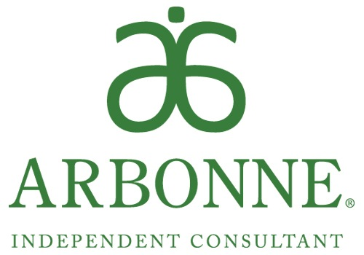

Cosmetics Graveyard Night!!!

6:30 p.m. Monday, October 19th

72 Donna, Chester

Bring Out Your Dead!

**For each "graveyard" product you bring and lay to rest, get the Arbonne replacement product at 20% off!**

Cash for Trash!!!

Do you have a spooky cabinet full of old, "rotting" skincare products?

A drawer full of lost and forgotten make-up that gives you the creeps?

Does your old routine make you look like a zombie?

Do you worry about toxic ingredients lurking in your products?

Scared yet? Now is the time to bury what doesn't work and get the results you want... Beautiful, young, smooth skin using the BEST in clean and healthy products!