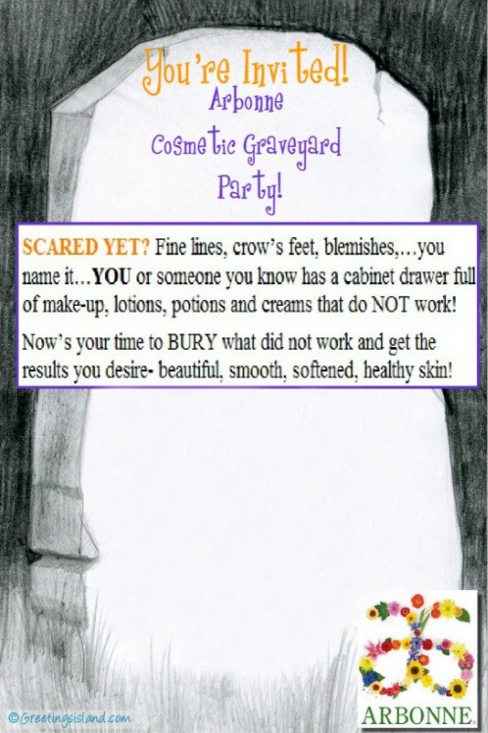

Date: Halloween!

Wednesday, October 31st

Time: 6:30-8:30 PM (Open House)

Location: Kristen & Amp Clapper’s House

1314 11th Street NE

Massillon, OH 44646

*Thank you for helping me pursue my dreams! :)*

*Kristin Clapper*

*Arbonne Independent Consultant*

*330.933.2382*

*kcap27@gmail.com*