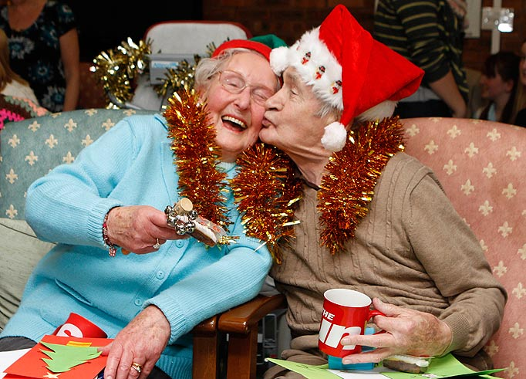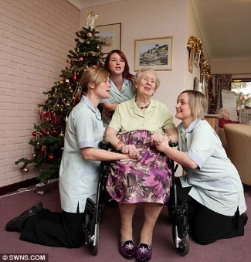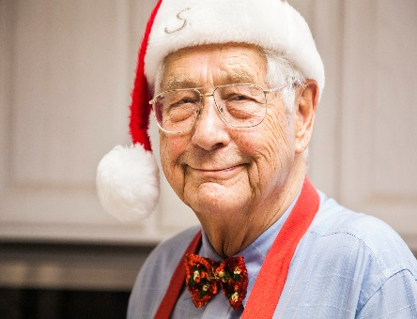
Join me in making a difference this Holiday season!
Adopt a Grandparent!!!!
We often remember the children, but don’t always think of the elders in our community who have done so much for our families and country!
For only $30 you can give a Pamper Duo to a senior in a local nursing home
For only $18 you can give half a duo which we will combine with others to make sure every senior gets a botanically based hand cream and foot cream!
Monetary donations of all sizes are welcome, valued and deeply appreciated
Our goal is to visit and hand deliver over 200 of these beautifully wrapped duos to 2 local nursing homes this holiday season!
Want to do an office drive? Make a big impact!
Sponsor 10 duos for $275 / 10 people donate 27.50 each
Sponsor 25 duos for $625 / 25 people donate 25 each

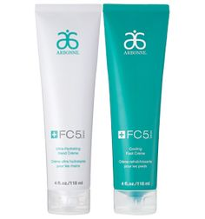

Shayne Devlin/Arbonne Independent Consultant/ shaynedevlin@comcast.net /603-78509611

